CS 255 System Design Document Template

Delbert Charles

UML Diagrams

UML Use Case Diagram
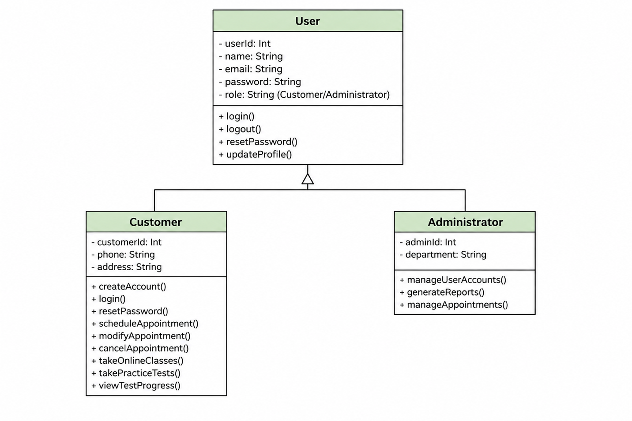

UML Activity Diagrams
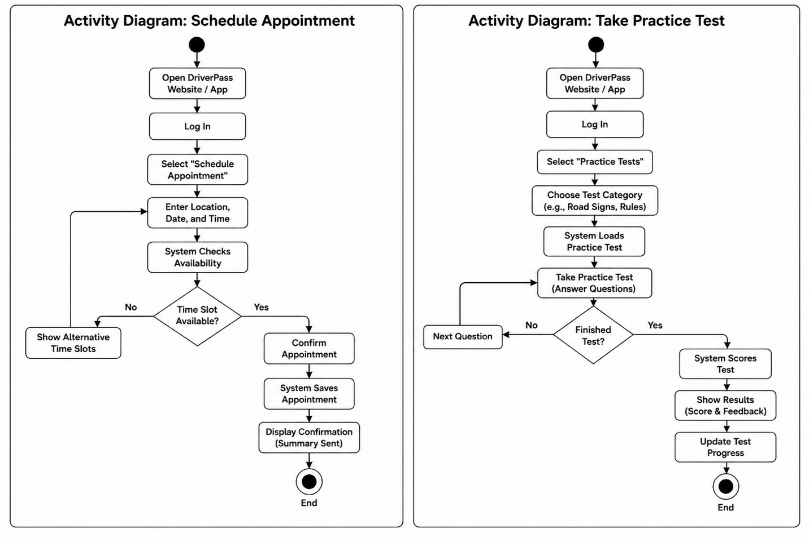

UML Sequence Diagram
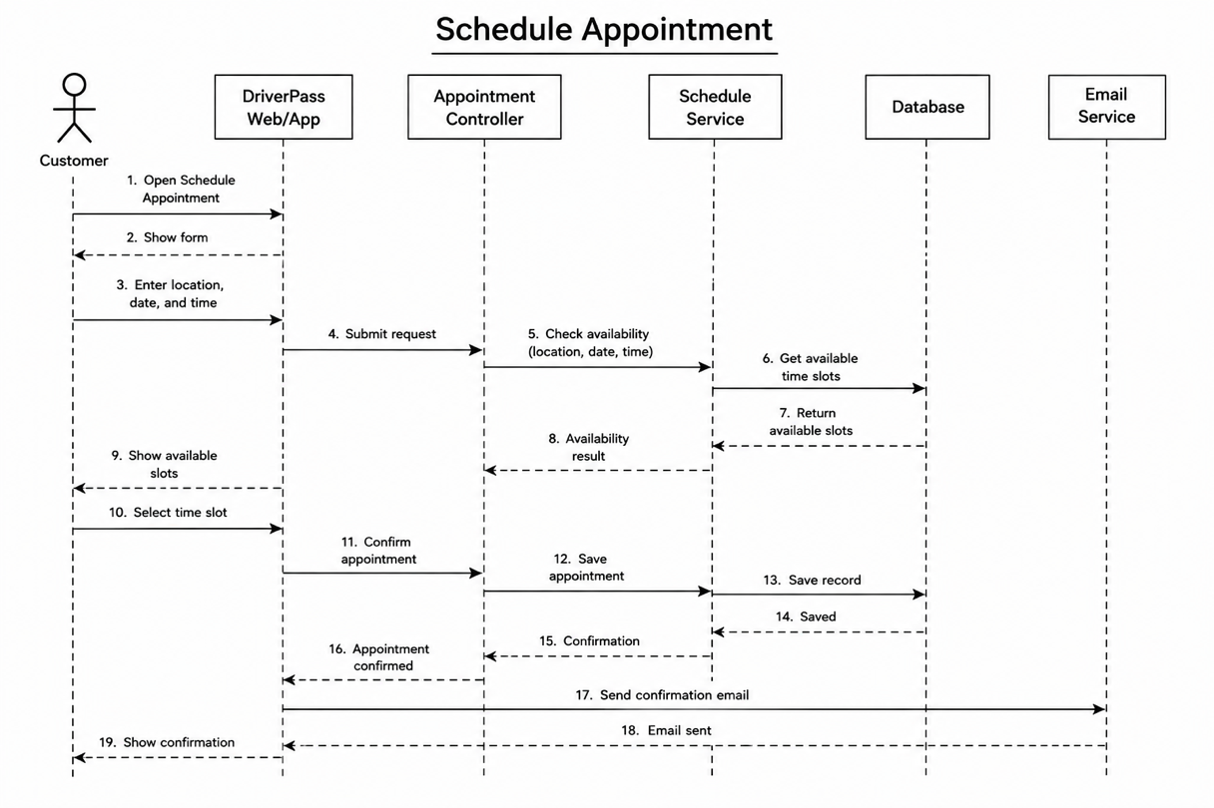

UML Class Diagram
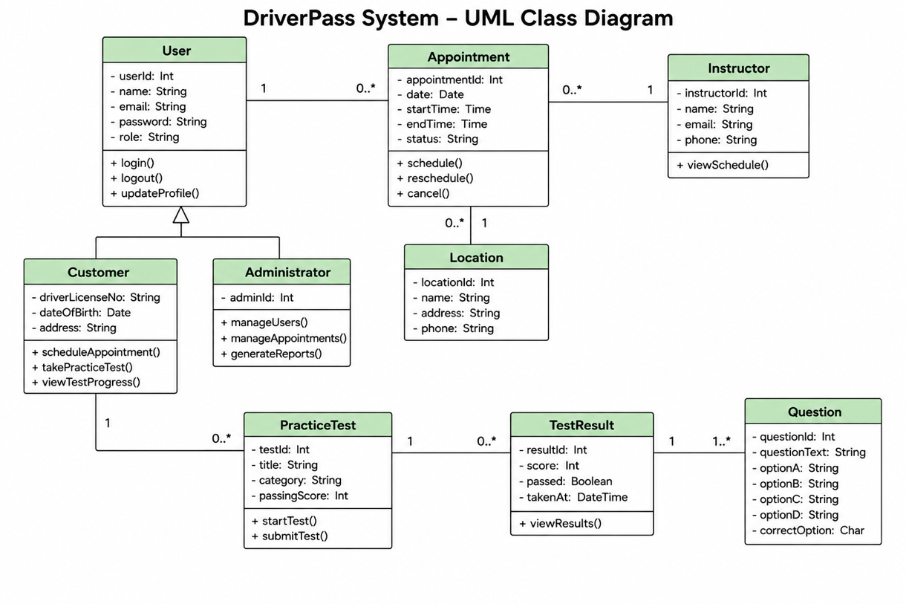

Technical Requirements
Hardware:
Computers, phones, tablets, and servers.
Software:
Web browser, database, and operating system (IOS, Android, Windows, Linux)
Tools:
Development software, Integrated Development Environments, Emulators
Infrastructure:
Internet, secure servers (Encryption), databases, and backups.

Sources
Object Management Group. (2017). OMG unified modeling language (OMG UML), version 2.5.1. https://www.omg.org/spec/UML/2.5.1/PDF

